
IN SEMESTER (INDIVIDUAL) ASSIGNMENT 2
Module Code: BUSS- B - 2001 | Module Name: Principles of Logistics

Student Names

Assignment Tasks

Task 1

• Understanding of deliverables – a detail description of deliverables
In Logistics, "deliverables" indicate the "project results" that go beyond any particular project's actual results. Besides, deliverables serve as a means of managing, planned, and executing a project. To be successful, one must be prepared to produce each deliverables process in a project in the best perfect manner. Projects are intended to create a unique, specific outcome, specific outcome. The project needs to have it is a policy, plan, process object r outcome. In this particular software development project, the key deliverable is "software code" and “project deliverables” as a specific project outcome. Process deliverables include means which project shall be executed, managed, and planned. This project takes multiple deliverables and processes to produce high quality and timely project deliverables as required and expected.
For this project, the deliverables are
- Project Reviews
- Project Budgets
- Project Schedule
- Government Plans
- Statement of Work
- Project Business Case

General overview of the proposed plan
Project Overview
As the transport planner for Visstick BV company a wholesaler in frozen fish fingers to refrigerated trucks, the products are affected by hot weather with more energy and resources required to keep the product cold. The variable cost increases as the temperature increases with the customers buying the products in whole pallets. The company transports the products to the customers personally.

Timeline for completion of the given tasks
Project Plan
Project Definition and Planning
Initiation and Conception of the Project | John N | 03/18/23 | 03/30/23 | 12 | 5%
Risk Management | Allen W | 03/26/23 | 04/06/23 | 11 | 30%
Communication Plan | John N |  |  |  | 10%
Budget | Malik M |  |  |  | 12%
Scope and Goal Settings
Project Performance / Monitoring | John N | 03/13/20 | 03/18/20 | 5 | 95%
Guidelines | Malik M | 03/13/20 | 03/18/20 | 5 | 95%
Project Study | Malik M | 03/13/20 | 03/18/20 | 5 | 80%
Forecasts | Kylie R | 03/20/23 | 03/22/23 | 2 | 30%
Shareholders | Steve L | 03/12/23 | 03/22/23 | 10 | 60%
Project Charter Revisions | John N | 03/13/23 | 03/22/23 | 9 | 50%
Project Initiation | John N | 03/18/23 | 03/23/23 | 5 | 40%
Project Agreement
Project Objectives | John N |  |  |  | 0%
Project Enactment and Routine | Allen W |  |  |  | 0%
Cost and Effort Tracking | Steve L |  |  |  | 0%
Quality Deliverables | Steve L |  |  |  | 0%
Project Launch and Execution
Status and Tracking | Malik M |  |  |  | 0%
KPIs | John N |  |  |  | 0%
Monitoring | Pete S |  |  |  | 0%
Forecasts | Kylie R |  |  |  | 0%
Project Updates | Malik M |  |  |  | 0%
Chart Updates | Pete S |  |  |  | 0%

Gantt Chart
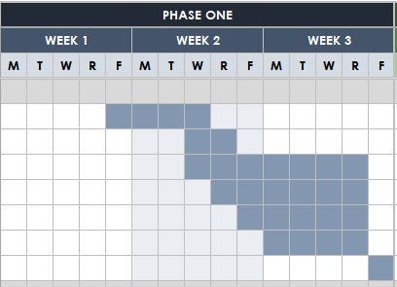

.

- Task 2: Case studies
Question 1.

Answer

Customer Journey Map
Customer Number | Persona | Post Code State | Journey (Including task) | Channels | Content
1 | Purmerend | 1447 | Netherlands Visstick BV frozen fish fingers | Netherlands | 4
2 | Tilberg | 3774 | Netherlands Visstick BV dry fish fingers | Netherlands | 6
3 | Drunen | 5256 | Netherlands Visstick BV frozen fish fingers | Netherlands | 8
4 | Putten | 3860 | Netherlands Visstick BV dry fish fingers | England | 10
5 | Dieren | 4640 | Netherlands Visstick BV dry fish fingers | England | 16

Based on the schedule table above, the company should adopt a scientific approach to forecast sales opportunities, logistical scheduling and visiting activity planning of those journey and visits planning to get around them most effectively. This ends up increasing the number of daily visits made by the company officers. The business merchandising and sales force shall acquire more prospects and customers when aligned visits schedules want to increase their resources and less workload to improve productivity. Equally, if one run types of field force, an improvement in operative to client allocation through logistics analysis will decrease operational expenses, reduce operating expenses, frequent visits and meeting duration with the most important clients.
Route planning comes with optimized visit schedules creating an optimum route sequence between locations (Bertsekas, 2016). The centers are preselected evaluating millions of field customer to sales per mutational visits. The intention of route planning is in the field and sales personnel at a specified time and less workload in the most productive way (Jedliński, 2015). Besides, the optimization feature contains CRM elements with logistics scheduling and planning. The CRM system technology does not apply road and geographical infrastructures. However, a combination of visits scheduling and CRM system software or services productivity needs to be maximized.
- Taking account of frequency calls, desired staff and access availability.
- Assessment of precise location with simulations
- Tactical and strategic scheduled visits
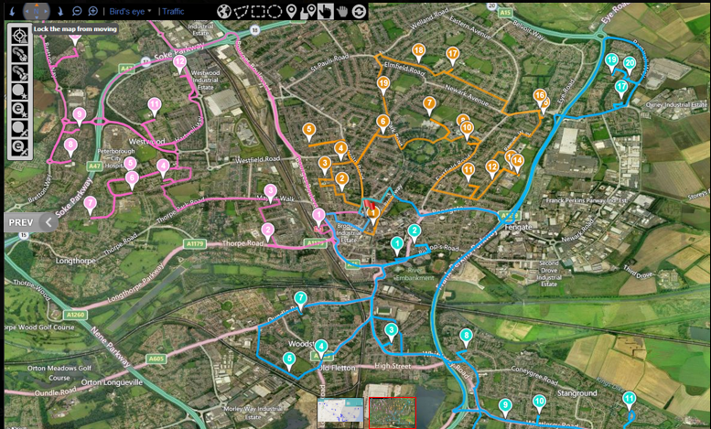
Optimized Journey Planning Visit Schedule
Considering Journey plan above, the field source has an equal number of prospects and customers. Besides, there is similar territorial sales capacity there will be a fluctuation in workload due to distance variation. Furthermore, customers' visits are dependent on several factors like customer fixed appointments, cycle and duration, frequency, sales visits, seasonality and opening hours. In some instances, customers need to be visited on specific days or particular support and sales staff.
In this regard, several factors are taken into account in field force scheduling leading to a 30% reduction in the total amount of time taken. In improving territorial coverage, the team optimizes overnight stays. The process is intended to increase efficiency by moving to vast geographical areas. Essentially, the team shall make 52 weeks planned, tactical and strategic visits (Vairaktarakis, Szmerekovsky, & Xu, 2016). The team also assesses the location with conducted simulations trips plan like overnight stays and sales lists.
The unit shall create monthly and weekly updates to undertake the logistical planning process for the services with delivered sequence planned visits in the form of a file structure and spreadsheet fed in the mobile device and CRM capturing system. The team also loads scheduled visits into the Geo-Planning Territory Runner including the formation of territory zones. The sub-territory divisions shall conduct geographical visits to allow easily scheduled visits within the same zones. In essence, a clear grasp of the customer journey ensures great interaction between customers and the company to achieve a common purpose (Christopher, 2016). The team conducts a sales schedule solutions, visit activity planning, and opportunity forecast solution. Considering these factors shall optimize the visit plan. The aim is to provide and accommodate the overnight states aimed at improving territorial coverage. The process aimed at improving efficiency in efficient geographical base planned workloads by exploring the priorities.

Exercise 2: Warehouse Layout and Design

In this exercise, we will be looking at the design and layout of a warehouse in more detail. The exercise will look at the company Compu, a medium-sized company that manufactures computer components, such as monitors, keyboards, HD recorders, processors, and computers, etc.

Question 2

- ABC analysis
Answer
ABC technique shall be applied in inventory management used by several types of companies and users. The process is based on the idea that all the inventory and products shall be divided into three categories.
The items require tight control with proper records and documentation set up to date. Therefore, the cost, number, place, and position properly updated and documented once a change happens. The items require to be placed in a less tight control but records and documentation properly maintained (Wang, & Meng, 2012). Here, every cost and number is recorded with a broad position but not exactly placed without tight control.
The items are not well controlled and documented normally done for fewer values and extra times’ ones.
In the example above, monitor and processor are the costliest items B and C placed in the A category. In this case, everything needs to be recorded, thus help the management easily after recorded. Items B and D categories are less controlled and documented. The other items in C managed and recorded controlled like the rest.

- Calculations for the ABC analysis

Answer
For the 80/20 model
Item | Cost | Numbers Sold | Total Earnings
C5 | 4029 | 721115 | 2.9E+09
C4 | 7029 | 794 | 5581026
C3 | 955 | 33779 | 3.2E+07
C2 | 755 | 29395 | 2.2E+07
C1 | 415 | 6276 | 2604540
P2 | 1029 | 518 | 533022
P1 | 529 | 1128 | 596712
D3 | 1029 | 261 | 268569
D2 | 325 | 1590 | 516750
D1 | 225 | 6470 | 1455750
T2 | 179 | 15827 | 2833033
T1 | 79 | 37061 | 2927819
B3 | 280 | 4904 | 1373120
B2 | 330 | 11978 | 3952740
B1 | 215 | 20485 | 4404275

- The logistics manager and the managing director disagree about whether the ABC analysis should be carried out using the sales figures or the turnover figures. Who is right if you look at the purpose of the analysis?

Answer
As per the numbers in turnover Category C has a maximum value that needs to be properly recorded with less attention or recording category. Considering the last category, D and P having the least turnover values placing less attention and category recorded (Xie, et al. 2020). In terms of Sales, Category C has maximum sales, and category D has the least sales. The two models are effective and good in their way but considering that the aim is to achieve the maximum sales value so should adopt 80/20 turnover model.

- Task 3: Completion of MOOC course (10 Marks)

MOOC link: https://www.mooc-list.com/course/supply-chain-management-be-global-coursera

You need to write a reflection (Word range 75-100 words) on what it was about and what was the learning you achieved. How is the course useful for your career and life? What are the challenges you faced in completing this course can be mentioned also. You need to attach screenshots of the course completion or the certificate as an evidence.

References
Bertsekas, D. (2016). Robust shortest path planning and semicontractive dynamic programming. Naval Research Logistics (NRL), 66(1), 15-37. https://doi.org/10.1002/nav.21697
Jedliński, M. (2015). DYNAMIC LOGISTICS STRATEGIES IN THE COMPANY LOGISTICS POTENTIAL MANAGEMENT. Russian Journal Of Logistics And Transport Management, 2(1), 3-10. https://doi.org/10.20295/2313-7002-2015-1-3-10
Vairaktarakis, G., Szmerekovsky, J., & Xu, J. (2016). Level workforce planning for multistage transfer lines. Naval Research Logistics (NRL), 63(7), 577-590. https://doi.org/10.1002/nav.21721
Wang, S., & Meng, Q. (2012). Robust schedule design for liner shipping services. Transportation Research Part E: Logistics And Transportation Review, 48(6), 1093-1106. https://doi.org/10.1016/j.tre.2012.04.007
Xie, J., Wong, S., Zhan, S., Lo, S., & Chen, A. (2020). Train schedule optimization based on schedule-based stochastic passenger assignment. Transportation Research Part E: Logistics And Transportation Review, 136, 101882. https://doi.org/10.1016/j.tre.2020.101882

